Suggested Social Posts

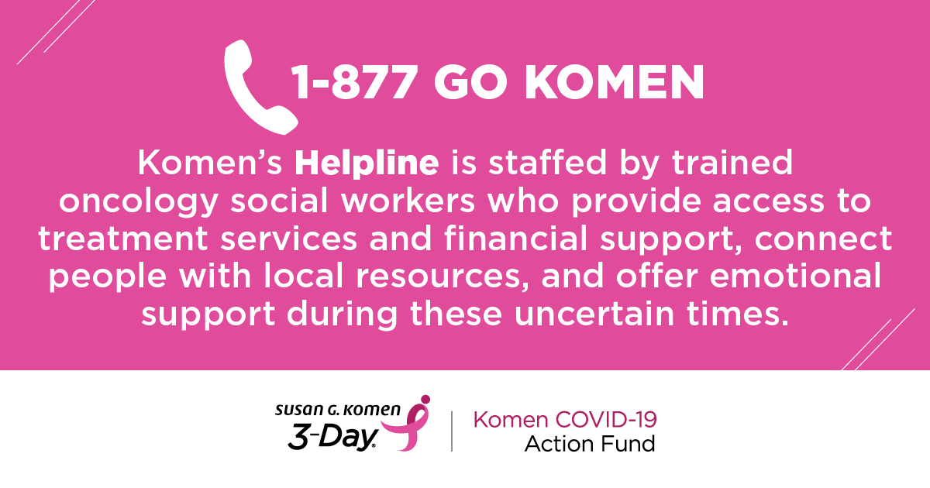
  - SUGGESTED POSTS w/graphic above:
    - Did you know Komen’s Breast Care helpline is experiencing increased demand for COVID-19 related concerns from those affected by breast cancer? Help ensure the Komen Helpline is well staffed to help those in need by donating to my 3-Day Fundraiser today! [Add link to your personal page.]
    - In this moment, we’re stronger together. That’s why I want to ensure Susan G. Komen’s free breast care helpline is well staffed and at the ready to answer important questions. Donate to my 3-Day fundraiser today! [Add link to your personal page.]

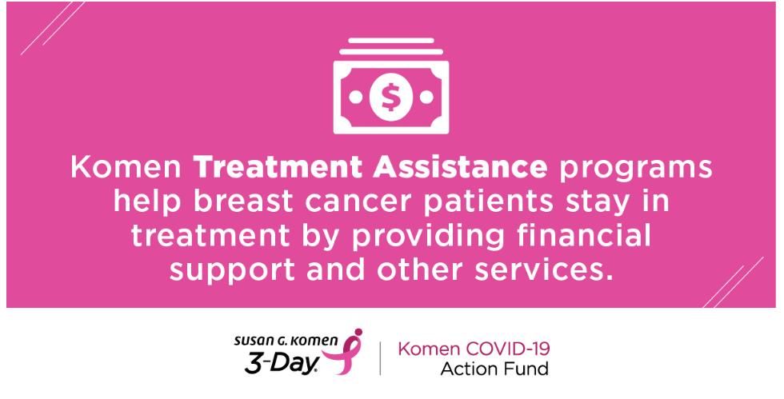
  - SUGGESTED POST w/graphic above:
    - Women should not be forced to make the hard choice of getting the lifesaving treatment they need or feeding their family. As many breast cancer patients find themselves out of work due to the COVID-19 pandemic, your help is needed more now than ever. Donate to my 3-Day Fundraiser today! [Add link to your personal page.]
    - Your donation to my 3-Day Fundraiser will help patients stay in treatment by guiding them through difficult decisions, offering financial assistance, and providing social and emotional support! [Add link to your personal page.]

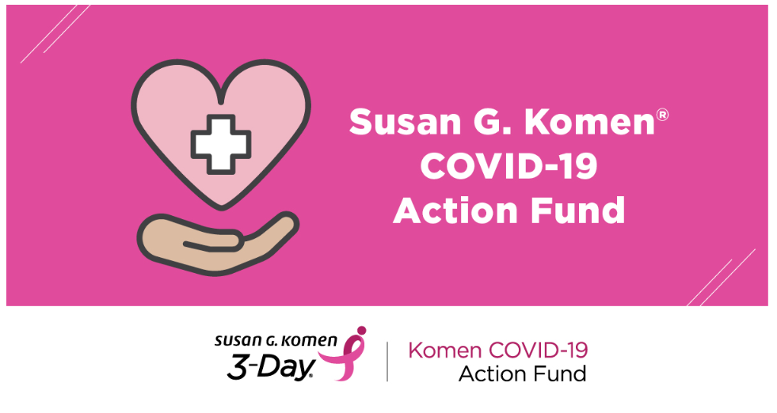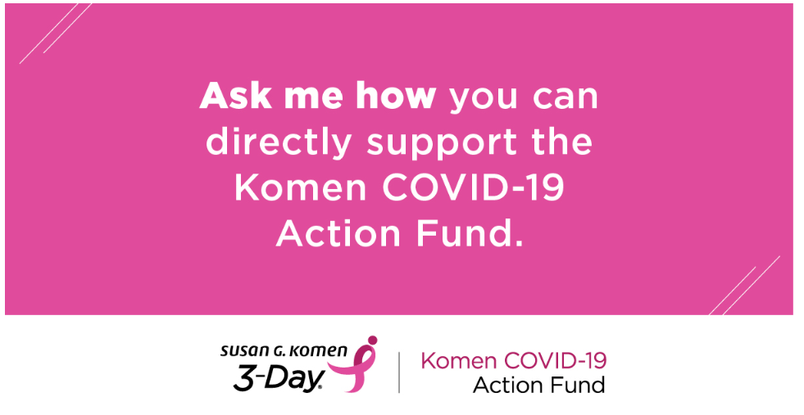

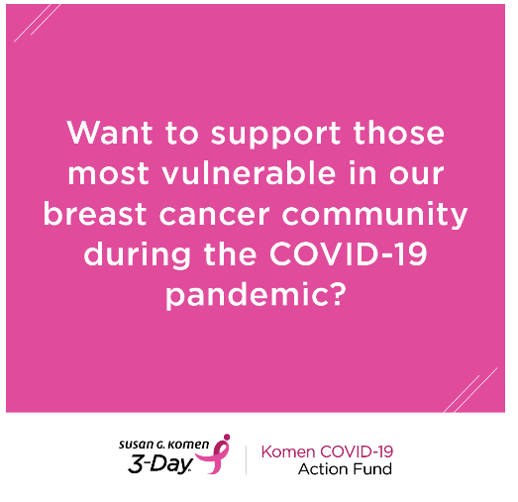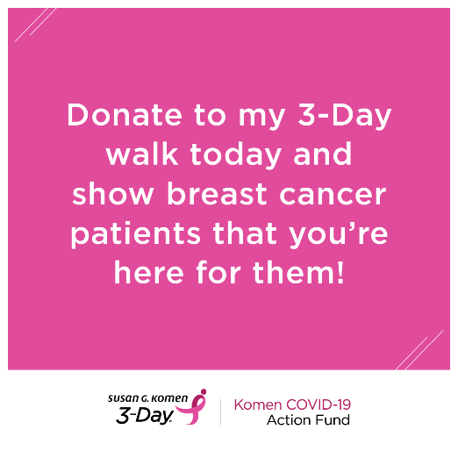

Suggested posts that could go with any of the above graphics:
- Donate to my 3-Day walk to support the urgent needs among our breast cancer community today and ensure that support continues in the future. [Add link to your personal page.]

- Please consider donating to my 3-Day walk. Your support will help make a difference for those who are among the most vulnerable to COVID-19 and the economic pressures it presents. [Add link to your personal page.]

- Today I’ve challenged myself to get [xx] donations for the 3-Day, to help support those most vulnerable to COVID-19. So far, I have [xx] donations (thank you [tag] [Insert Name], [Insert Name], and [Insert Name]!); can you help me get [xx] more? Make your donation now! Or if you’ve already donated, please share this request! [Add link to your personal page.]

- During these uncertain times, I’m committed more than ever to reach my 3-Day fundraising goal to support urgent needs among those most vulnerable in our breast cancer community. Please help me reach my goal and donate today. [Add link to your personal page.]

- During these uncertain times, I’m committed more than ever to reach my 3-Day fundraising goal to support those in our community that are at highest risk of COVID-19. Please help me reach my goal and donate today. [Add link to your personal page.]

- All donations to my 3-Day goal go directly to the Komen COVID-19 Action Fund supporting the urgent needs of our breast cancer community today and ensuring support continues into the future. [Add link to your personal page.]

